Pokhara University

Level: Bachelor | Semester – Spring | Year : 2005
Programme: BE |  | Full Marks : 100
Course: Numerical Methods |  | Time : 3hrs.

Candidates are required to give their answers in their own words as far as practicable.
The figures in the margin indicate full marks.

Attempt all the questions.

1. | Find the real root of the function   - Bisection method with initial values 2.3 and 2.4  - Newton-Raphson method with initial value 2.2.  - Secant method with initial values 2.3 and 2.4  In each case, perform only five iterations. | 5  5  5
2. | Fit the second order polynomial a₁x²+a₂x+a₃ = 0 from given data using least square method. Use Gauss Seidel method to solve the equation from the following data: | 15
X | 1 | 2 | 3 | 4
Y | 6.0 | 11.0 | 18.0 | 27.0

3. | a) Integrate 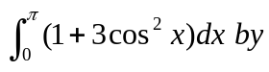  i) Trapezoidal rule  ii) Simpson's 3/8 rule, taking number of intervals (n)= 6  b) Use Romberg integration to evaluate 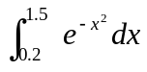 correct to 3 significant digits. | 9  6
4. | a) Solve the following system of equations using Gauss elimination method with partial pivoting. 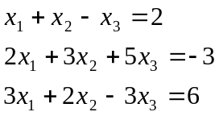  b) Determine the highest Eigen value and its corresponding eigenvector for the following matrix using power method. 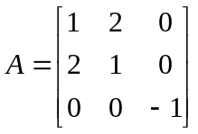 | 7  8
5. | Use the classical Runge-Kutta method to estimate y(0.4) of the following equation with h = 0.2.  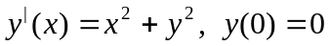 | 15
6. | Solve the Poisson's equation 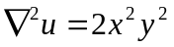 over the square domain 0 <x <3 and 0 < y <3 with Dirichlet boundary condition of u(x, y) = 0 and h = k = 1 using Gauss-Seidel method. | 15
7. | Write short notes on (Any Two):  - Convergence of Newton Raphson method  - Pivoting in solution of a set of Linear equations.  - Errors in Numerical computing. | 2x5

